# Fandom

## Definition

**# Source**: **Windows ScreenShots (using Lightshot Program) From Site -> https://www.fandom.com/ at [9/3/2025]**

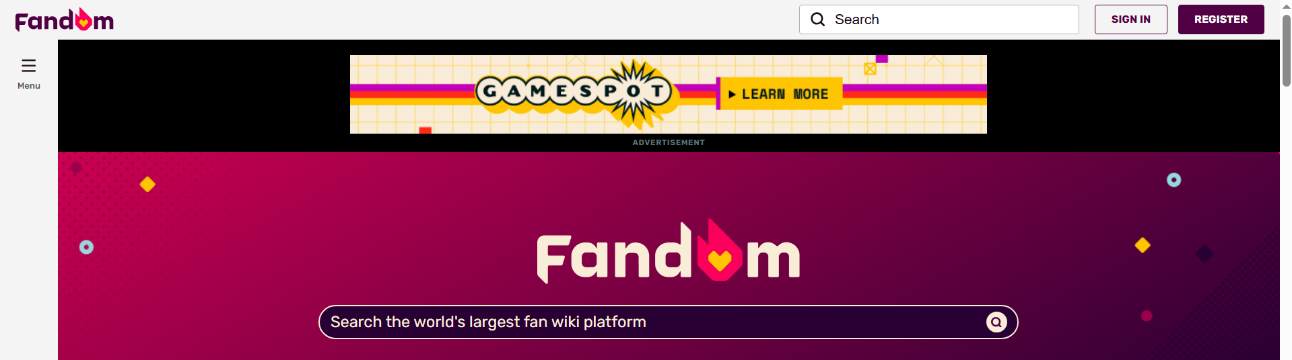

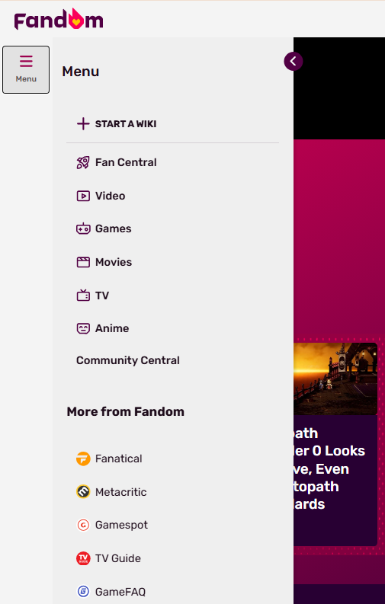

**# Source**: **Chatgpt (GPT-5-Standard) at [9/3/2025]**

**Fandom** (formerly known as **Wikia**, and before that **Wikicities**) is a **wiki-hosting platform and entertainment site**—a place where fans can create, edit, and explore wikis dedicated to TV shows, movies, video games, books, and other pop-culture topics ([Wikipedia](https://en.wikipedia.org/wiki/Fandom_%28website%29?utm_source=chatgpt.com), [Simple Wikipedia](https://simple.wikipedia.org/wiki/Fandom_%28website%29?utm_source=chatgpt.com)).

## Key Highlights

**# Source**: **Chatgpt (GPT-5-Standard) at [9/3/2025]**

* **Origins & Evolution**
  + Launched in **October 2004** as *Wikicities*, rebranded to *Wikia* in 2006, and finally became **Fandom** around **2016–2018** ([Simple Wikipedia](https://simple.wikipedia.org/wiki/Fandom_%28website%29?utm_source=chatgpt.com), [Wikipedia](https://en.wikipedia.org/wiki/Fandom_%28website%29?utm_source=chatgpt.com)).
* **Platform Details**
  + Built on **MediaWiki** software—the same engine that powers Wikipedia—though customized and maintained by Fandom, Inc., a **for-profit company** ([Wikipedia](https://en.wikipedia.org/wiki/Fandom_%28website%29?utm_source=chatgpt.com), [WebCatalog](https://webcatalog.io/en/apps/fandom?utm_source=chatgpt.com)).
  + Hosts **hundreds of thousands of wikis** with millions of pages covering virtually every fandom imaginable ([wikis.fandom.com](https://wikis.fandom.com/wiki/Fandom?utm_source=chatgpt.com), [Fandom](https://about.fandom.com/about?utm_source=chatgpt.com)).
* **Content & Community**
  + Offers both wiki services and editorial content—this includes news, reviews, and features related to entertainment and gaming ([Fandom](https://about.fandom.com/what-is-fandom?utm_source=chatgpt.com), [Fandom](https://www.fandom.com/?utm_source=chatgpt.com)).
  + Registration is **optional**—anyone can read; editing and creating generally require an account ([Wikipedia](https://en.wikipedia.org/wiki/Fandom_%28website%29?utm_source=chatgpt.com), [Simple Wikipedia](https://simple.wikipedia.org/wiki/Fandom_%28website%29?utm_source=chatgpt.com)).

## How It Works

**# Source**: **Chatgpt (GPT-5-Standard) at [9/3/2025]**

1. **Explore Existing Wikis**  
   You can browse wikis on topics like *Star Wars*, *Minecraft*, *Harry Potter*, or *One Piece*—with thousands more available ([Fandom](https://www.fandom.com/), [wikis.fandom.com](https://wikis.fandom.com/wiki/Fandom?utm_source=chatgpt.com)).
2. **Create or Edit a Wiki**  
   Registered (and email-confirmed) users can start their own community wiki—provided the topic isn't already covered—and build pages collaboratively ([community.fandom.com](https://community.fandom.com/wiki/Help%3AStart_a_new_community?utm_source=chatgpt.com)).
3. **Rich Fan-Generated Content**  
   Pages often include lore summaries, character bios, gameplay walkthroughs, maps, fan theories, and more—crafted by enthusiasts for enthusiasts ([Wikipedia](https://en.wikipedia.org/wiki/Fan_wiki?utm_source=chatgpt.com)).

## Pros & Cons

**# Source**: **Chatgpt (GPT-5-Standard) at [9/3/2025]**

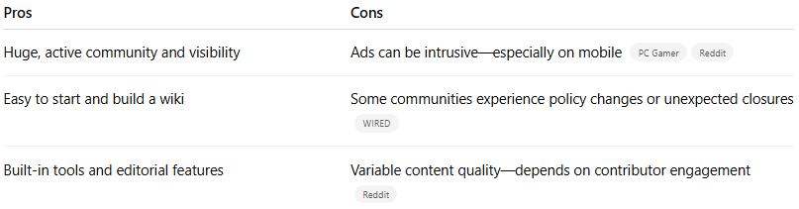

| **Pros** | **Cons** |
| --- | --- |
| Huge, active community and visibility | Ads can be intrusive—especially on mobile ([PC Gamer](https://www.pcgamer.com/games/fallout/indie-fallout-wiki-joins-forces-with-the-unofficial-elder-scrolls-pages-ensuring-a-bright-future-for-looking-up-rpg-lore-uninterrupted-by-half-page-video-ads/?utm_source=chatgpt.com), [Reddit](https://www.reddit.com/r/assholedesign/comments/146l9qr/fandom_the_website_that_lets_people_make_custom/?utm_source=chatgpt.com)) |
| Easy to start and build a wiki | Some communities experience policy changes or unexpected closures ([WIRED](https://www.wired.com/story/how-fans-saved-sexypedia-from-being-erased-from-the-internet?utm_source=chatgpt.com)) |
| Built-in tools and editorial features | Variable content quality—depends on contributor engagement ([Reddit](https://www.reddit.com/r/FanFiction/comments/ngdjsz/how_trustworthy_is_fandomcom/?utm_source=chatgpt.com)) |

Many fan wikis have flourished thanks to Fandom’s infrastructure, but there's also a rising trend of communities migrating to **independent or non-Fandom hosts**—like **UESP** or **Miraheze**—for fewer ads or more stability ([PC Gamer](https://www.pcgamer.com/games/fallout/indie-fallout-wiki-joins-forces-with-the-unofficial-elder-scrolls-pages-ensuring-a-bright-future-for-looking-up-rpg-lore-uninterrupted-by-half-page-video-ads/?utm_source=chatgpt.com)).

## **Summary**

**# Source**: **Chatgpt (GPT-5-Standard) at [9/3/2025]**

**Fandom.com** is a **massive wiki platform and entertainment portal** created for fans, by fans. It allows users to build and collaborate on fandom-specific wikis—plus browse news, reviews, and original content related to entertainment and gaming.